Industrial Internship Report on
"Smart URL Shortener Using Python"
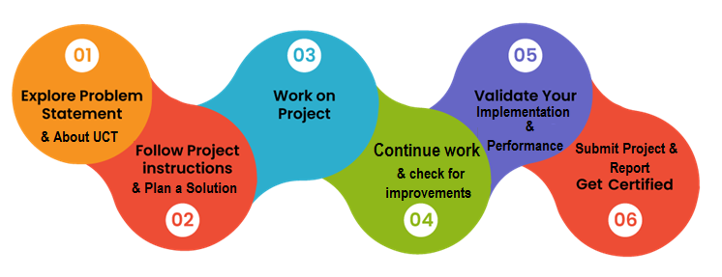
Prepared by
SNEHA BANIK
Electronics & Communication Engineering (ECE)
Institute of Technical Education and Research (ITER), SOA University
Executive Summary
This report provides details of the Industrial Internship provided by upSkill Campus and The IoT Academy in collaboration with Industrial Partner UniConverge Technologies Pvt Ltd (UCT).
This internship was focused on a project/problem statement provided by UCT. The project, including the report, was completed within a 6-week timeframe.
My project was a Smart URL Shortener built in Python — a desktop application with a Tkinter-based GUI that converts long URLs into short, shareable links and stores the mapping in a local SQLite database, with an option to view all saved records.
This internship gave me a very good opportunity to get exposure to industrial problems and to design/implement a solution for one. It was an overall great experience to have this internship.

TABLE OF CONTENTS
1 Preface 3
2 Introduction 4
2.1 About UniConverge Technologies Pvt Ltd 4
2.2 About upSkill Campus (USC) 5
2.3 The IoT Academy 5
2.4 Objectives of this Internship program 5
2.5 Reference 6
2.6 Glossary 6
3 Problem Statement 7
4 Existing and Proposed solution 7
4.1 Code submission (Github link) 7
4.2 Report submission (Github link) 7
5 Proposed Design/ Model 8
5.1 High Level Diagram 8
5.2 Low Level Diagram / Module Breakdown 8
5.3 Interfaces 8
6 Performance Test 9
6.1 Test Plan/ Test Cases 9
6.2 Test Procedure 9
6.3 Performance Outcome 9
7 My learnings 10
8 Future work scope 10

Preface
This report summarizes the work carried out over the 6-week Industrial Internship program.
Internships are an essential part of career development — they bridge the gap between academic learning and industry practice, giving students the chance to apply theoretical knowledge to real, practical problems under professional guidance.
For this internship, my assigned project/problem statement was to design and build a "Smart URL Shortener" application using Python — a lightweight, offline-capable tool to convert long URLs into short codes and manage them through a simple desktop interface.
This opportunity was made possible by upSkill Campus (USC) and The IoT Academy, in collaboration with Industrial Partner UniConverge Technologies Pvt Ltd (UCT).
The program was structured over 6 weeks — starting with orientation to UCT and the problem statement, moving through solution design and implementation, and concluding with testing, validation, and report submission.

Working on this project improved my practical skills in Python programming, GUI development, database design, and following a structured, industry-style development workflow. Overall, it was a valuable and enriching experience.
I would like to thank the mentors and coordinators at upSkill Campus and UniConverge Technologies Pvt Ltd for their continuous guidance and support throughout this internship.
To my juniors and peers: make the most of this opportunity — it teaches you far more about real-world engineering than a classroom ever can. Start early, ask questions, and document your work as you go.

Introduction

About UniConverge Technologies Pvt Ltd
A company established in 2013 and working in the Digital Transformation domain, providing Industrial solutions with a prime focus on sustainability and RoI.
For developing its products and solutions, it leverages various Cutting Edge Technologies e.g. Internet of Things (IoT), Cyber Security, Cloud computing (AWS, Azure), Machine Learning, Communication Technologies (4G/5G/LoRaWAN), Java Full Stack, Python, Front end, etc.

UCT Insight is an IoT platform designed for quick deployment of IoT applications while providing valuable "insight" for a business process. It is built in Java for the backend and ReactJS for the front end, with support for MySQL and various NoSQL databases.
- It enables device connectivity via industry-standard IoT protocols — MQTT, CoAP, HTTP, Modbus TCP, OPC UA
- It supports both cloud and on-premises deployments.
It has features to build your own dashboard, analytics and reporting, alerts and notifications, integration with third-party applications (Power BI, SAP, ERP), and a rule engine.
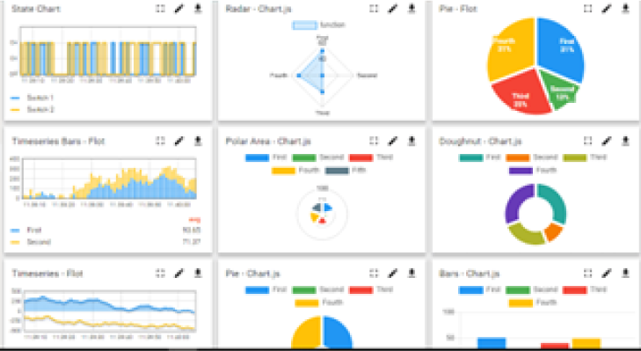
Factory Watch is a platform for smart factory needs, providing users/factories:
- A scalable solution for production and asset monitoring
- OEE and predictive maintenance solutions scaling up to digital twins for assets
- The ability to unleash the true potential of the data their machines generate, identifying and improving KPIs
- A modular architecture that lets users start small and scale to more complex solutions as needed
Its unique SaaS model helps users save time, cost, and money.
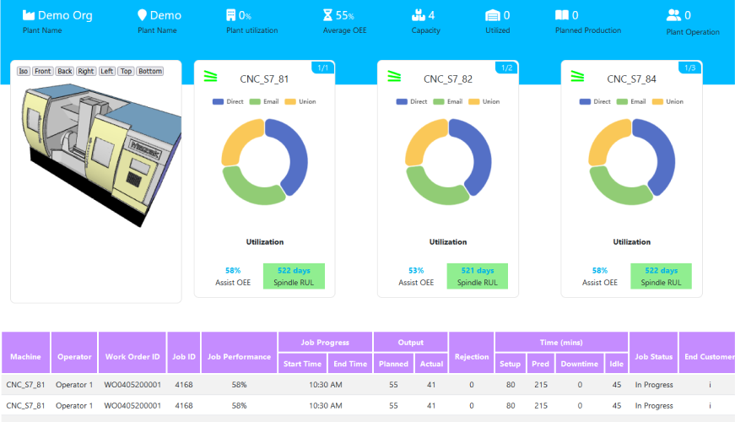
UCT is also one of the early adopters of LoRaWAN technology, providing solutions in Agritech, Smart Cities, Industrial Monitoring, Smart Street Lighting, and Smart Water/Gas/Electricity metering. Additionally, UCT provides Industrial Machine health monitoring and Predictive Maintenance solutions by leveraging Embedded Systems, Industrial IoT, and Machine Learning to estimate the Remaining Useful Life of machines used in production.
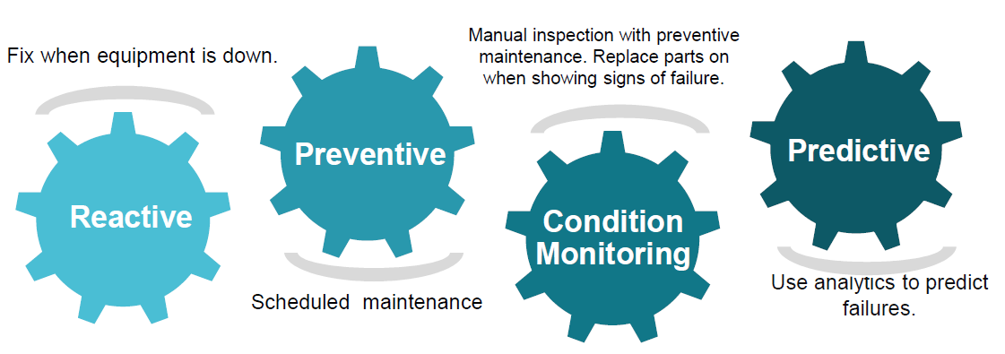

About upSkill Campus (USC)
upSkill Campus, along with The IoT Academy and in association with UniConverge Technologies, has facilitated the smooth execution of the complete internship process.
USC is a career development platform that delivers personalized executive coaching in a more affordable, scalable, and measurable way.

The IoT Academy
The IoT Academy is the EdTech division of UCT, running long executive certification programs in collaboration with EICT Academy, IITK, IITR, and IITG across multiple domains.

Objectives of this Internship program
The objectives of this internship program were to:
- Get practical experience of working in the industry
- Solve real-world problems
- Improve job prospects
- Gain an improved understanding of the field and its applications
- Support personal growth — better communication and problem-solving skills

Reference
[1] UniConverge Technologies Pvt Ltd — https://www.uniconverge.co/
[2] upSkill Campus — https://www.upskillcampus.com/
[3] Python Software Foundation — https://docs.python.org/3/

Glossary
Term | Acronym
Uniform Resource Locator | URL
Graphical User Interface | GUI
Structured Query Language (used by SQLite) | SQL
Application Programming Interface | API
Industrial Internet of Things | IIoT

Problem Statement
Long URLs are common across the web — product pages, tracked marketing links, documents, and deep links — but they are difficult to share, easy to mistype, and visually unwieldy when pasted into chats, forms, or printed material.
Most existing solutions (Bit.ly, TinyURL, etc.) are web-based services that require an active internet connection, depend on a third-party server, and often rate-limit or paywall heavy usage.
The assigned problem statement was to design and build a lightweight, Python-based URL Shortener that works as a standalone desktop utility: it should accept a long URL, generate a short, unique code for it, persist the mapping locally, and allow the user to retrieve or browse previously shortened links — all without depending on an external hosted service.

Existing and Proposed solution

Existing Solutions
Popular services like Bit.ly, TinyURL, and Rebrandly provide URL shortening as a hosted, cloud-based service. Their limitations for a lightweight/offline use case include:
- Mandatory internet connectivity and dependency on the provider's servers being online
- Usage limits, account requirements, or paid tiers for higher volumes
- No easy way to keep a fully private, local record of shortened links
- Limited control over how short codes are generated or stored

Proposed Solution
A desktop application, Smart URL Shortener, built entirely in Python, that:
- Provides a simple Tkinter-based GUI (gui.py) to enter a long URL and instantly get a shortened version
- Generates a unique short code for each URL using the logic in url_shortener.py, with helper/validation functions in utils.py
- Persists every URL mapping locally in a SQLite database (urls.db) managed through database.py
- Includes a dedicated view_data.py module to browse, search, and review all previously shortened URLs

Value Addition
Compared to hosted shorteners, this solution works fully offline, keeps all data private and local, and is easy to extend — the modular structure (separate GUI, logic, and data layers) makes it straightforward to add features like custom aliases, click analytics, or a future web front-end.

Code submission (Github link)
https://github.com/baniksneha90/upskillcampus.git

Report submission (Github link)
https://github.com/baniksneha90/upskillcampus.git

Proposed Design/ Model
The application follows a simple, modular, layered design — user input flows from the GUI, through the shortening logic, into persistent local storage, and can be viewed back through a data-browsing module.

High Level Diagram
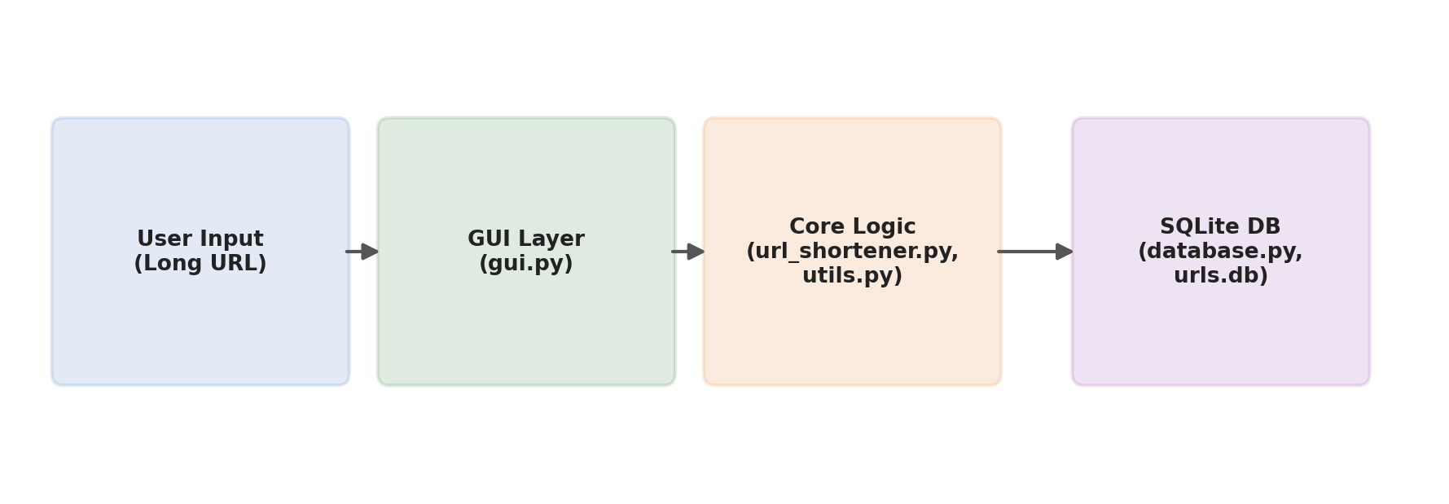
Figure 1: High-Level Architecture of the Smart URL Shortener

Low Level Diagram / Module Breakdown
- main.py — Entry point; launches the application and wires the GUI to the backend modules
- gui.py — Tkinter GUI: input field for the long URL, a 'Shorten' button, and a display area for the result
- url_shortener.py — Core logic: generates a short, unique code for each submitted URL (e.g., via hashing/random alphanumeric generation) and checks for collisions
- utils.py — Helper functions: URL validation, formatting, and small reusable utilities used across modules
- database.py — Manages the SQLite connection, table creation, and CRUD operations against urls.db
- urls.db — SQLite database file storing the long URL ↔ short code mapping
- view_data.py — Reads and displays all stored URL records for review

Interfaces
The GUI (gui.py) is the only interface exposed to the end user. Internally, gui.py calls into url_shortener.py to generate/resolve short codes, which in turn calls database.py to persist or fetch records from urls.db. view_data.py talks directly to database.py to list stored records. No network interface is required, since all data flows and storage are local.

Performance Test
This is an important part of the report — it explains why this work is meant for real usage, rather than being just an academic exercise.
For a lightweight local utility like this, the key constraints considered were correctness (does every long URL map to a valid, resolvable short code), uniqueness (no two different URLs collide on the same short code), and responsiveness (the GUI should not lag on typical use).

Test Plan / Test Cases
# | Test Case | Expected Result | Status
1 | Enter a valid long URL and click Shorten | A unique short code is generated and displayed | Pass
2 | Enter an invalid/malformed URL | Application shows a validation error, no DB entry created | Pass
3 | Shorten the same long URL twice | Existing short code is reused / handled without duplication | Pass
4 | View saved records via view_data.py | All previously shortened URLs are listed correctly | Pass
5 | Close and reopen the application | Previously stored mappings persist (SQLite file retained) | Pass

Test Procedure
Each test case was executed manually through the GUI: launching main.py, entering the specified input, and observing the displayed output and the corresponding entry (or lack thereof) in urls.db, cross-checked using view_data.py.

Performance Outcome
All core test cases passed. URL shortening and lookups were effectively instantaneous for a local SQLite database at this scale, and the GUI remained responsive throughout testing. No collisions were observed in short-code generation during testing.

My learnings
This internship strengthened my practical Python programming skills, particularly around building a GUI application with Tkinter and structuring a project into clean, reusable modules (GUI, business logic, data access, and utilities).
I gained hands-on experience with SQLite for lightweight local data persistence, including schema design and basic CRUD operations, and learned how to design short-code generation logic that avoids collisions.
Beyond the technical skills, I learned how to work to a defined problem statement and timeline, document my work as I went, and present a finished project the way it would be expected in an industry setting. This experience will help me approach future software projects with a more structured, production-minded mindset.

Future work scope
- Extend the desktop app into a web application (Flask/Django) so links can be shortened and resolved from a browser
- Add custom aliases, letting users choose their own short code instead of a generated one
- Add click analytics — track number of visits, timestamps, and referrers per short link
- Add link expiry / auto-deletion after a configurable period
- Generate a QR code for each shortened URL for easy mobile sharing
- Move storage from local SQLite to a cloud-hosted database for multi-device access

